This is a list of all parts and materials that will be used to manufacture the silencer. No parts or materials have been sourced for this silencer and will not be procured until this application has been reviewed and approved.
General Purpose Aluminum Tubing, 2" OD, 0.065" Wall Thickness From mcmaster.com
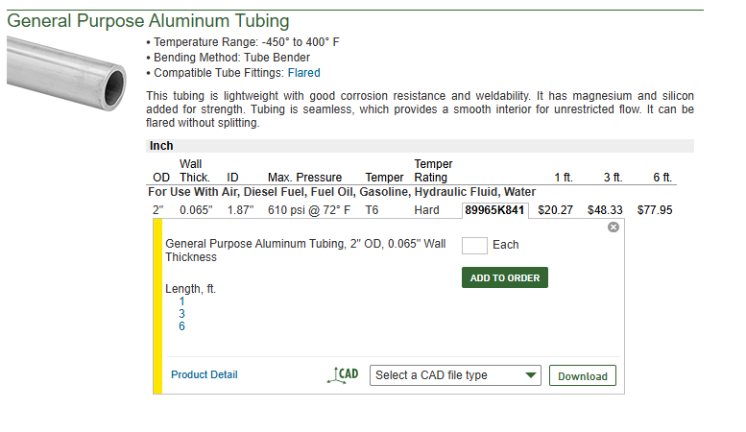
KAK INDUSTRY MICRO SLIMLINE FLASH CAN From kakindustry.com
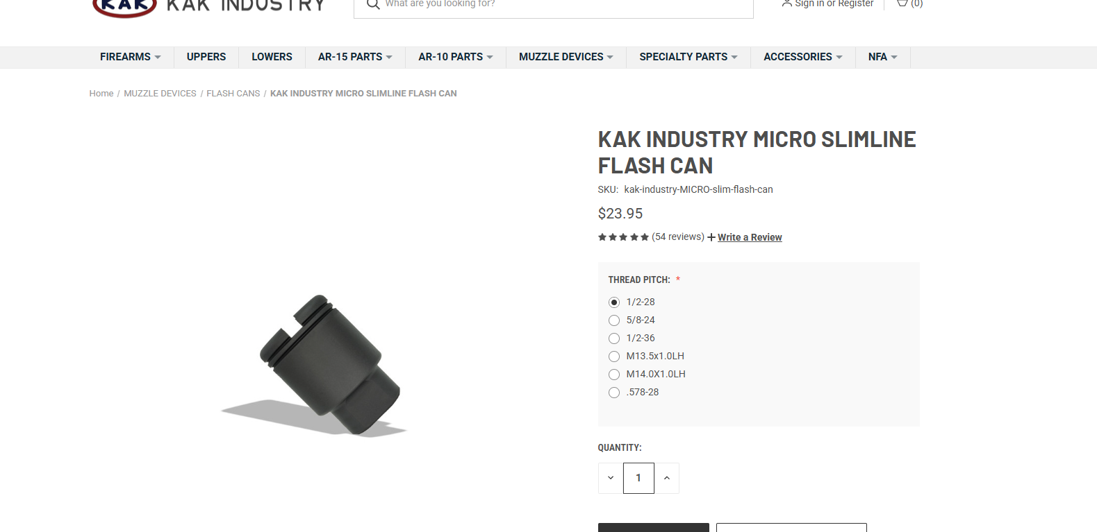

J-B Weld 8281 Professional Size Steel Reinforced Epoxy - Hardener and Steel Pack - 10 oz From Amazon.com
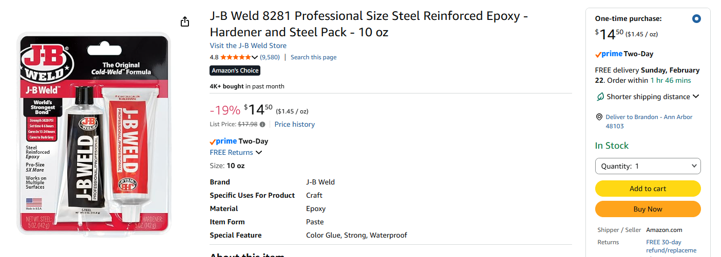
Polymaker Fiberon PA6-CF20 Carbon Fiber Nylon Filament 1.75mm Black 0.5kg, Fiberon PA6-CF Nylon Warp Free 1.75mm 3D Printing Filament From Amazon.com
